CMPG 223 Group Project

Student Accommodation Program

**MS Nxumalo**

**35383615**

Lecturer(s): Mr. Nathan Morgenrood & Mr. Heinke Lubbe

Student Accommodation Program

1. **Introduction:**

The Student Accommodation Program aims to create a comprehensive and user-friendly system that securely manages, maintains, and controls accommodation reservations for tertiary students throughout the duration of their studies. The system will provide students with the ability to browse and choose accommodations of their choice before their arrival. It will also enable Real Estate Agents to handle accommodation management and lease agreement approvals, ensuring a seamless and efficient accommodation booking process for both students and agents.

1. **Problem Statement:**

The current student accommodation process lacks an efficient and user-friendly system to manage, maintain, and control accommodation reservations for tertiary students during their study period. This leads to various challenges and inconveniences for both students and Real Estate Agents involved in the process. There is a need for a comprehensive solution that can securely facilitate the entire accommodation booking process, from browsing available options to finalizing lease agreements, ensuring a seamless and hassle-free experience for all stakeholders.

* 1. **Key Issues:**
* **Inefficient Accommodation Management:** The existing process lacks a centralized system to effectively manage and oversee the accommodation reservations for tertiary students. This often results in miscommunications, delays, and errors in booking procedures.
* **Limited Student Accessibility:** Current accommodation reservation methods offer limited options for students to browse and select suitable accommodations before their arrival at the educational institution. This restricted access can lead to unsatisfactory living conditions for students during their study period.
* **Lengthy Lease Agreement Approvals:** Real Estate Agents face challenges in handling accommodation management and lease agreement approvals manually, leading to time-consuming processes that delay the booking of accommodations for students.
* **Lack of Security and Data Privacy:** The absence of a secure system poses potential risks in managing sensitive personal information and financial details of both students and Real Estate Agents, making it necessary to implement robust data protection measures.
  1. **Objectives:**

The goal of the Student Accommodation Program is to develop a comprehensive and user-friendly system that addresses the aforementioned issues and achieves the following objectives:

* **Streamline Accommodation Management:** Implement a centralized platform that efficiently manages, tracks, and updates accommodation reservations for tertiary students, reducing administrative burdens and enhancing communication among all stakeholders.
* **Enhance Student Experience:** Provide a user-friendly interface that enables students to browse, compare, and select accommodations according to their preferences and budget, enhancing their overall experience during their study period.
* **Expedite Lease Agreement Approvals:** Design a streamlined process for Real Estate Agents to handle accommodation management and lease agreement approvals, ensuring faster and smoother bookings for students.
* **Ensure Data Security and Privacy:** Implement robust security measures to protect the personal and financial data of students and Real Estate Agents, complying with all relevant data protection regulations.

1. **Features and Functionality:**
   1. **Accommodation Management:**

* The system will maintain a database of all available accommodations, including flats, apartments, and houses, with various specifications such as location, type, capacity, rent, facilities, and available dates.
* Real Estate Agents will have the authority to manage accommodation details, including adding new accommodations, updating information, and marking accommodations as unavailable when booked.
  1. **Student Account Registration and Profile Management:**
* Prospective students will need to register an account on the system to access accommodation options.
* Students will provide their personal details, contact information, course-related information, and any specific preferences for accommodations.
  1. **Accommodation Reservation:**
* Registered students can browse through available accommodations, view detailed information, and select their preferred accommodation based on their requirements.
* Students can reserve the chosen accommodation in advance, securing their housing before their arrival at the institution.
  1. **Real Estate Agent Management:**
* The system will store profiles of Real Estate Agents, including their names, contact details, and credentials.
* Agents will be assigned specific accommodations to manage and approve lease agreements for the respective accommodations.
  1. **Payment Processing:**
* Students can make rental payments through the system using secure payment gateways.
* The system will record all payment transactions for financial tracking and future reference.
  1. **Lease Agreement Approval:**
* Students can sign lease agreements for the selected accommodations through the system.
* The relevant Real Estate Agent assigned to the accommodation must approve the lease agreement before it becomes effective.
  1. **Accommodation Maintenance Logging:**
* Students can log accommodation maintenance requests, such as repairs, replacements, or cleaning, for each accommodation.
* Agents will be responsible for tracking the resolution status of each maintenance request.

1. **User Roles and Permissions:**

* **Prospective Students:** Can register, browse available accommodations, make reservations, sign lease agreements, and make payments.
* **Registered Students:** Have access to all features mentioned for prospective students, along with the ability to update their profile information.
* **Real Estate Agents:** Have access to accommodations assigned to them, can manage accommodation details, approve lease agreements, and log maintenance requests.

1. **Limitations:**

* The system will not guarantee accommodation availability; it will only assist in reservation and management.
* The program will not be responsible for any legal aspects of lease agreements beyond recording their approval status.

1. **Technology Stack:** The Student Accommodation Program will be developed using the following technology stack:

* Programming Language: C#
* Framework: Windows .NET Framework
* Database: SQL Server
* Reports & Visualization: Excel & Power BI

1. **Project Timeline:** The project timeline will be divided into the following FAST methodology phases:

* Scope definition
* Problem analysis
* Requirements analysis
* Logical design
* Decision analysis
* Physical design and integration
* Construction and Testing
* Installation and Delivery

1. **User Documentation:** Comprehensive user documentation will be provided to guide students, real estate agents, and administrators on how to use the Student Accommodation Program effectively. It will include explanations of features, tutorials, and troubleshooting tips.
2. **Use Case Diagram:**

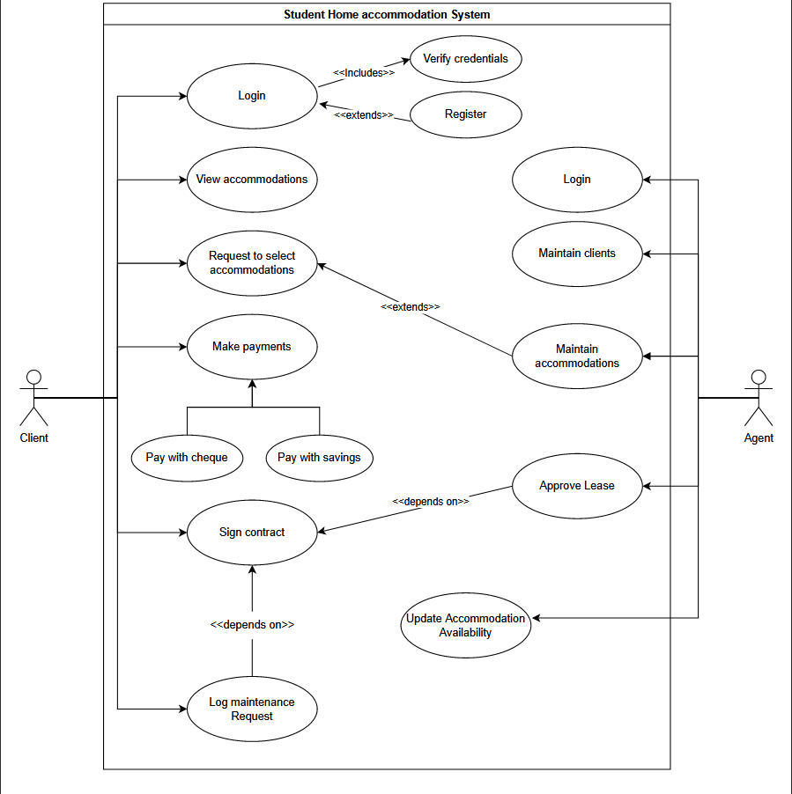

1. **ER Diagram**

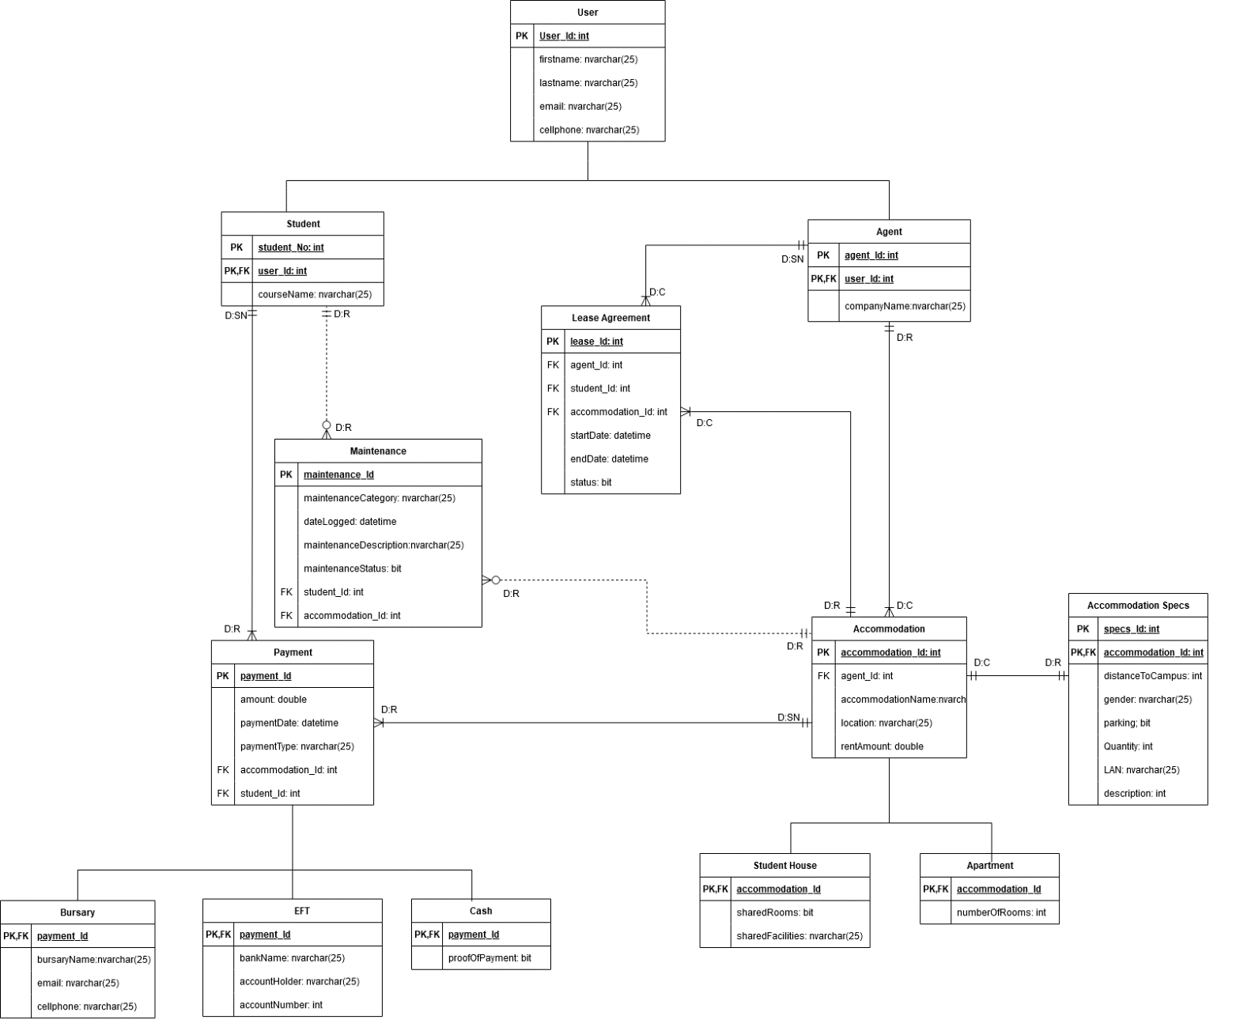

1. **Process Model**

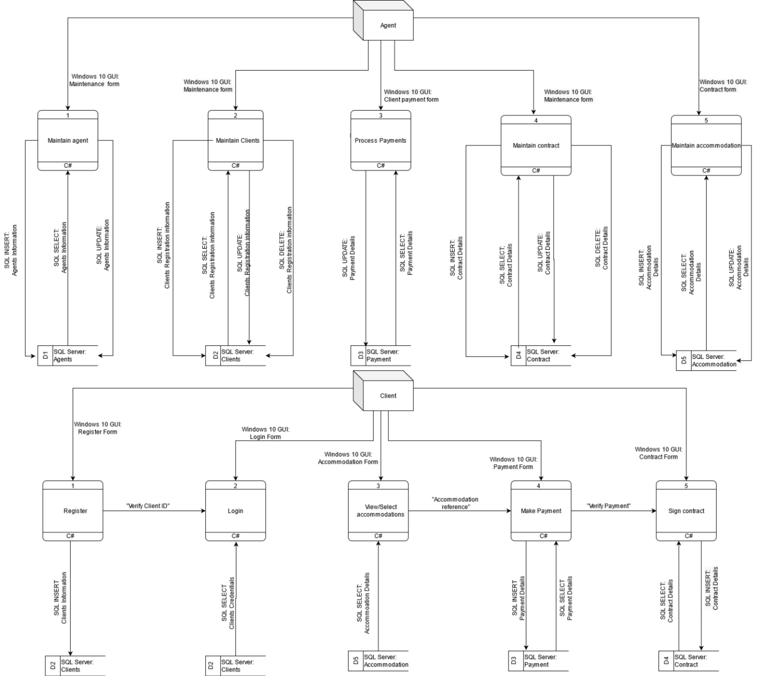

# Heading 1 won’t print. Don’t delete – doing so will lead to incorrect numbering.